Fighting for a LeadFreeDC
The DC Council Is Considering a New Law to Create Stronger Protections Against Lead- Paint Hazards
Do you live in a DC home built before 1978? If the answer is yes, it almost certainly contains lead paint—in fact, almost 90 percent of DC homes do. That’s why childhood lead exposure is a big problem here in DC. The Lead Hazard Prevention and Elimination Amendment Act of 2019 – a bill under consideration by the DC Council – will help address this problem.

The Dangers of Lead-Based Paint
The most common source of lead poisoning in children is lead-based paint and dust in buildings built before 1978. Without proper maintenance, lead-based paint chips and dust can wind up on floors, walls and window sills. That’s how lead comes in contact with young children, who like to crawl on the floor and put things in their mouth.
Lead can cause serious health risks for all members of the home. But children under age 6 are especially vulnerable. Lead exposure can cause irreversible harm to children, including:
- Brain damage resulting in IQ loss, learning disabilities, hyperactivity and behavior issues;
- Stunted growth; and
- Hearing problems.

The New Law Will:
- Require more frequent lead inspections in rental housing, which is critical in catching lead-based paint hazards before they harm children.
- Require landlords to provide a lead clearance report to all prospective tenants before signing the lease (current law only requires report when new tenant includes a pregnant women or child under 6).
- Update technical standards and requires more effective tests for lead dust.
- Help ensure compliance:
  - DC government must deny business licenses to landlords who violate lead laws;
  - Tenants can take their landlord to court to force compliance and recover damages;
  - Tenants entitled to 2 months’ rent abatement if they are victims of landlord retaliation; and
  - A fund is established to defray abatement costs for landlords who demonstrate financial hardship in certain circumstances.

Our goal should be “zero tolerance for lead hazards.”

- Center for Disease Control Advisory Committee on Childhood Lead Poisoning Prevention

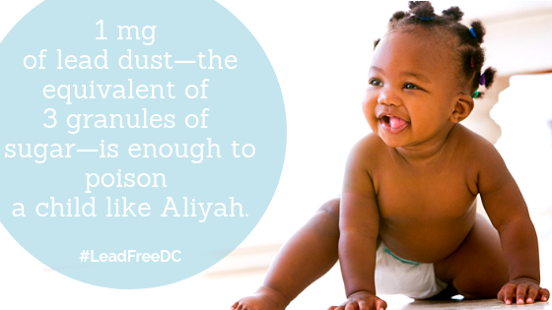

Phone
202.467.4900 x507

EmaiL
blogan@childrenslawcenter.org

Contact Information:
Buck Logan

